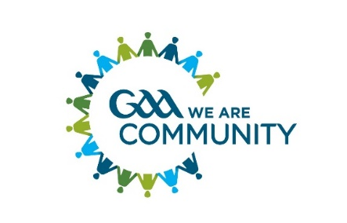ABOUT US – KERRY HEALTH & WELLBEING COMMITTEE

The County Health and Wellbeing committees aim to help the Association to identify and respond to the wellbeing needs of its members, both directly through GAA health-related programmes and through signposting to and partnering with relevant national and local agencies who can provide services that may be of use to our members.

Actions and activities carried out by Kerry GAA Health and Wellbeing Committee are based on the Strategic Action Plan which in turn connects to the GAA’s National Strategic Action Plan.

The Kerry Health and Wellbeing Committee actions and activities cover a wide range including the Social Initiative, Tobacco, Gambling, Alcohol & Drug Education, Mental Fitness Initiative, Inclusion and Integration Initiative, Youth Initiative, to better work with clubs. The Committee also partners with a number of agencies locally including South West Counselling Centre, Jig Saw Kerry, TIRC and KASI, Kerry Mental Health Association, and both locally and nationally with The HSE/HealthyIreland, NOSP(National Office for Suicie Prevention), The RNLI and The Samaritans (the GAA’s mental health partners).

All clubs are encouraged to appoint a Healthy Club Officer whoses role replaces the role of the Healthy and Wellbeing Officer and previously the ASAP Officer. This is intended to better reflect the broad nature of health promoting work the Association is engaged in.

The chairperson and Secretary of the Kerry Health and Wellbeing Committee are members of the Munster Health and Wellbeing Group.

If you are passionate about health and would like to be part of this exciting element of the Association then why not consider taking up the role and play your part in making your club and Ireland a healthier place to grow up and grow old in.

Chairperson of the Kerry Health and Wellbeing Committee:
Jimmy Mulligan e mail: chair.hwc.kerry@gaa.ie and jimmy.mulligan@outlook.com

Committee members:
Jimmy Mulligan, (Cathaoirleach, St Pats Blenerville CLG), Bridget Hartnett(Runaí, Beaufort C.L.G.), Frank O’ Rahilly (Ballymacelligott C.L.G.), Eileen Bunyan(Ballydonoghue C.L.G.), Caroline Somers (Tralee Parnells C.L.G.), Áine Ní Shuilleabhain (Glenflesk C.L.G. County Children’s Officer).

The Committee and its partners welcome opportunities to work with clubs in progressing the various initiatives and in supporting clubs in their actions and acitivites.

Details of the Kerry Health and Wellbeing Committee and their partners and the Actions and Initiatives run under the auspices of the committee are summarised in the below attachments.

