**Coiste Chontae Chiarraí C.L.G.**

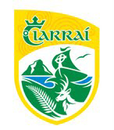

**Responding to a Critical Incident**

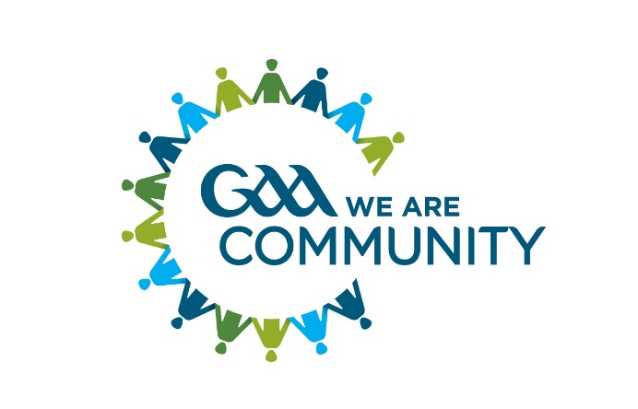

**A Guide for GAA Units & Members**

**Introduction**

A critical incident is any event that causes an unusually intense stress reaction which has the emotional power to overwhelm an individual’s usual ability to cope. It may impede people’s coping mechanisms immediately or in the future following the event. (GPA/GAA guidelines, 2014)

**Critical Incidents and why to plan for them**

People have remarkable coping skills and mechanisms however at times we can all use a helping hand in overcoming the challenging events life occasionally presents us with.

Sometimes a critical incident – one that overwhelms one’s natural capacity to respond – will arise leaving individuals or communities struggling to cope. GAA clubs and counties have proven themselves invaluable in supporting their members’ and communities in responding to an array of tragic and seemingly insurmountable situations.

It is important to remember that the GAA club or unit is usually just one entity within a community affected by a critical incident (including, perhaps, amongst others, the local school(s), youth club, emergency and primary/secondary care services, churches/pastoral centres etc). No

GAA unit is expected to take on the burden of responding alone – help is out there if required. Of the utmost importance is ensuring that any families involved remains at the centre of any response.

It is important to remember that individuals and families are central and must be heard first.

***Examples of critical incidents may include the following but the below list is not exhaustive:***

• Death, death by suicide or serious injury, on or off the playing field

• Witnessing or Exposure to a serious accident or incident e.g. a road traffic accident scene,

• Personal loss or injury, real or threatened to a child or adult

• Being violently threatened or assaulted

• A situation with excessive media interest

• A natural disaster

**Lines of effective communication**

If club officers/members/coaches feel excessively challenged or inadequately prepared to deal with a situation it is always better to err on the side of caution. Effective communication is one of the key principles when responding to a critical incident. Effective lines of communication will help GAA units access any support they need both within the Association and external to it.

When reporting or seeking support a unit should contact their county health & wellbeing committee chairperson in the first instance, who will notify Croke Park if necessary. In extreme cases the club may contact Croke Park directly for support and guidance.

**Figure 1: Recommended Avenues for communicating a Critical Incident**



**Our role in responding to critical incidents**

Experts have encouraged following these **5 Key Principles** during any crisis situation or

critical incident.

1. Promote a sense of safety
2. Promote a sense of calm
3. Promote a sense of ability/capacity to deal with the situation
4. Promote a sense of connectedness
5. Promote a sense of hope

These simple yet effective steps help support personal and collective responses to any critical incident.

**Supports are out there**

It’s important to remember that the GAA will usually be just one entity playing a part in any response to a critical incident.



**Figure 2: Some potential participants involved in a community based response to a critical incident**

In addition to the individuals directly affected, other ‘at risk’ persons are amongst those most likely to suffer distress as a consequence of an incident.

Evidence would suggests that these may include those who:

* are family members or friends of those immediately affected
* directly witnessed death/injury/violence as part of the incident
* are uninjured, but were at greatest risk
* may blame themselves and/or those who may be blamed by others
* are experiencing instability at home
* have learning difficulties
* have pre-existing emotional and behavioural/mental health difficulties
* are vulnerable due to cultural and/or language difficulties
* have previously suffered bereavement or loss

**(GAA/GPA Critical Incident Response Information and Guidelines, 2014)**

By identifying **key roles and duties** in advance of an incident there will be a clear statement of who will do **what, when and how**. A good plan also ensures that no individual is overburdened and that important elements in the response are not forgotten.

**School**





**Good practice tips**

The following is a summary of some good practice tips to follow:

* Always consult with those affected to see what level of support they want from the club, if any.
* **Be familiar with all the appropriate local services and** agencies that are available and ensure that the contact numbers are checked and updated every year. This is really an invaluable exercise.

For a one stop directory of recognised national & local services go to [***www.yourmentalhealth.ie***](http://www.yourmentalhealth.ie)or Information Line:1800111 888or [**https://kerrychildrensservices.com/cypsc-publications-resources/**](https://kerrychildrensservices.com/cypsc-publications-resources/)

To ensure consistency of message, only one person should deal with any media inquiries.



**Critical Incident Response Plan Coiste Chontae Chiarraí**

**Lead Liaison Person:** Jimmy Mulligan

Cathaoirleach

County Health & Wellbeing Committee

Contact No: 087 - 698 7700

Email: [chair.hwc.kerry@gaa.ie](mailto:chair.hwc.kerry@gaa.ie)

**Alternative Liaison Person:** Patrick O’Sullivan

Cathaoirleach,

Coiste Chontae Chiarraí

Contact No: - 086-237 7187

Email: [chairperson.kerry@gaa.ie](mailto:chairperson.kerry@gaa.ie)

**Media Liaison Person:** Leona Twiss, County PRO

Contact No: 087-984 0125

**Review Date:** At least annually at the first Meeting of the County Health and Wellbeing Committee after the Annual County Convention

**By:** The County Health & Wellbeing Committee