-------------------------------------------------------------------------------------------------------------------------------------------

JIG SAW KERRY
At Jigsaw, we understand young people’s mental health. Both online and in our services around the country, we give advice and support to help young people aged 12–25 years-old. If you, or someone you know needs mental health support, we are here for you.
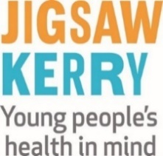
You can call us for free on 1800 544 729, or visit www.jigsaw.ie

Phone: 066 7186785; E mail: kerry@jigsaw.ie
---------------------------------------------------------------------------------------------------------------------------------------------
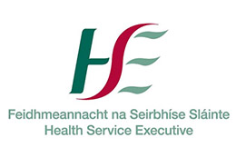

THE HSE: www.hse.ie
------------------------------------------------------------------------------------------------------------------------------------------------
THE SAMARITANS www.samaritans.org/ireland/branches/tralee/ 43 - 44 Moyderwell, Tralee
Phone: 116 123 free from any phone; 0330 094 5717 local call charges apply

------------------------------------------------------------------------------------------------------------------------------------------------
KERRY MENTAL HEALTH ASSOCIATION www.kerrymentalhealth.com
Voluntary organisation that supports people with Mental Health difficulties 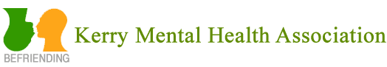

SOUTHWEST COUNSELLING CENTRE www.southwestcounselling.ie
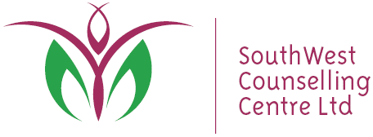
A community based counselling organisation, providing accessible
and affordable Play Therapy and Counselling/Psychotherapy for all ages

Phone: 064 - 6636 416; E mail info@southwestcounselling.ie

