SOUTHWEST COUNSELLING CENTRE: www.southwestcounselling.ie
Phone: 064 - 6636 416; E mail info@southwestcounselling.ie
Provides affordable mental health support in the community.
-------------------------------------------------------------------------------------------------------
JIG SAW KERRY: www.jigsaw.ie/kerry
Phone: 066 7186785; E mail: kerry@jigsaw.ie
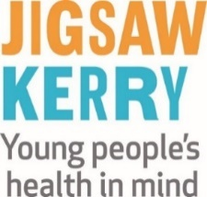
---------------------------------------------------------------------------------------------------------------------------
THE HSE: www.hse.ie
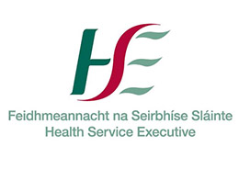

----------------------------------------------------------------------------------------------------------------------------
THE SAMAMIRTANS: www.samaritans.org/ireland/branches/tralee/ 43 - 44 Moyderwell, Tralee
Phone: 116 123 free from any phone; 0330 094 5717 local call charges apply
-----------------------------------------------------------------------------------------------------------------------------
KERRY MENTAL HEALTH ASSOCIATION: www.kerrymentalhealth.com
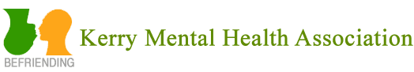
Voluntary organisation that supports people with Mental Health difficulties
RNLI - Tel: 01-8900 460 or email SusanCarthy@rnli.org.uk
Will deliver water safety talks to GAA clubs in their local communities, including minor & senior teams
----------------------------------------------------------------------------------------------------------------------------------

