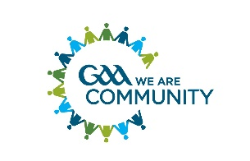INCLUSION & INTEGRATION INITIATIVE

The GAA reaches into every corner of Ireland and many communities around the globe and is fully committed to the principles of inclusion and integration at all levels.

WHAT IS INCLUSION & INTEGRATION?
Inclusion
The idea that everyone should be able to use the same facilities, take part in the same activities, and enjoy the same experiences, including people who have a disability or other disadvantage.
Integration
“It's very difficult to integrate yourself into a society whose culture is so different from your own”.

Kerry County Committee has adopted a proactive approach to inclusiveness and integration and over the last 7 years or so and a number of initiatives have been run to welcome more people into the GAA family.

These initiatives range from bringing together children of all abilities from throughout the county to learn the skills of our games to promoting participation in all aspects of GAA activities to a wider audience.

Initiatives run to date have included
- ‘Come and Try’ days for foreign nationals, in association with Kerry County Council
- Extending a welcome hand to refugee children to join GAA clubs
- Rounders blitz and ‘Games for All’ programme which has been run by students from the Sporting Chance programme at National Learning Network Tralee.
  - The latter is an inclusive Gaelic Football coaching programme open to all children aged 7 to 14 years who wish to gain additional coaching.
  - In particular, the programme aims to provide Gaelic football skills training specifically to children with additional needs.
  - The sessions focus on developing basic football skills as well as agility and coordination, all in a fun environment. Parents have especially welcomed these sessions.

Ballydonoghue CLG, which is participating in phase 3 of the Healthy Club project (2018 to 2019) have run the Fun N Run Game, as one of their 2 chosen projects.
The Inclusion and Integration Sub Committee run a number of initiatives during the year.

For further details and updates on current Initiatives click into the below documents.

