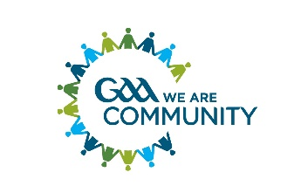 Introduction to Kerry GAA Critical Incident Response Plan

Introduction
A critical incident is any event that ........ causes an unusually intense stress reaction which has the emotional power to overwhelm an individual’s usual ability to cope. It may impede people’s coping mechanisms immediately or in the future following the event. (GPA/GAA guidelines, 2014)

Critical Incidents and why to plan for them
People have remarkable coping skills and mechanisms however at times we can all use a helping hand in overcoming the challenging events life occasionally presents us with.
Sometimes a critical incident –one that overwhelms one’s natural capacity to respond –will arise leaving individuals or communities struggling to cope. GAA clubs and counties have proven themselves invaluable in supporting their members’ and communities in responding to an array of tragic and seemingly insurmountable situations. It is important to remember that the GAA club or unit is usually just one entity within a community affected by a critical incident (including, perhaps, amongst others, the local school(s),youth club, emergency and primary/secondary care services, churches/pastoral centres etc.). No GAA unit is expected to take on the burden of responding alone –help is out there if required. Of the utmost importance is ensuring that any families involved remains at the centre of any response. It is important to remember that individuals and families are central and must be heard first.
Examples of critical incidents may include the following but the below list is not exhaustive:
• Death, death by suicide or serious injury, on or off the playing field
• Witnessing or Exposure to a serious accident or incident e.g. a road traffic accident scene,
• Personal loss or injury, real or threatened to a child or adult
• Being violently threatened or assaulted
• A situation with excessive media interest
• A natural disaster

See below attachment - The Kerry GAA Critical Incident Response Plan

