All clubs that participate in the Healthy Club project receive Official Recognition as a Healthy Club through this project – see photographs at the end of this article.
Clubs go through the process over an 18 month to 2 year period .
Clubs partcipating in the Healthy Club Project focus on 2 health areas as well as adopting a club Critical Incidence Response Plan (CIRP).
The Kerry GAA County Critical Incident Response Plan, which can form a template for the club CIRP is on the County GAA Web Site in the Health & Wellbeing Section under Club Zone: www.kerrygaa.ie/club-zone

Update re Phase 4 GAA Healthy Clubs Project

There are 5 Kerry GAA Clubs participating in Phase 4 of the Healthy Clubs Project. Applications to take part in this phase of the project opened in October 2019 and closed in November 2019.

The 5 Kerry CLG which are taking part in Phase 4 of the project are:

ARDFERT & ST BRENDANS HURLING C.L.G. (JOINT), BALLYMACELLIGOTT C.L.G., KEEL C.L.G., TEMPLENOE C.L.G. & SPA CLG.
These 5 clubs join the 4 clubs that participated in Phase 3 of the project. These are:
BALLYDONOGHUE C.L.G., DR CROKES C.L.G., BEAUFORT C.L.G. & TRALEE PARNELLS C.L.G.

Phase 4 of the GAA National Healthy Club Project

Phase 4 of the Healthy Club Project got under way in February 2020, with an orientation day in Croke Park.
All clubs participating received training in the Healthy Club Project
Due to Covid 19 Pandemic and associated restrictions, many projects are on hold currently.
Templenoe CLG held an drug awareness event in Kenmare on Friday 7 February 2020

Phase 3 of the GAA National Healthy Club Project
Phase 3 of the Healthy Club Project got under way in 2018.
In Kerry, Ballydonghue CLG and Dr Crokes CLG took part in the Healthy Club Project Phase 3 and both clubs were awarded Healthy Club Certificates in Croke Park, on 7th October 2019 .
Beaufort CLG and Tralee Parnells CLG – The 2 Kerry clubs that pariticpated successfully in Phase 2 of the project, received their Helathy Club certificates in October 2018.
All clubs that participate in the Healthy Club project receive Official Recognition as a Healthy Club through this project.
Clubs go through the process over an 18 month- 2 year period (Phase 3 started in April 2018, with a Munster club orientation evening in Mallow).
Club partcipating in the Healthy Club Project focus on 2 health areas as well as adopting a club Critical Incidence Response Plan (CIRP).
The Kerry GAA County Critical Incident Response Plan is on the County GAA Web Site in the Health & Wellbeing Section under Club Zone.
There is also further information on the National GAA website at http://www.gaa.ie/my-gaa/community-and-health/community-development/cirp

Projects/initiatives undertaken by Ballydonoghue C.L.G. in Phase 3 of the Healthy Club Project
Two Chosen Projects during this were
- Smoke Free Clubrooms & Grounds.
The clubs grounds in Coolard are Smoke Free since Jan 1st. 2019
- Fun N Run Game.
This game is for children of all abilities and also includes children with disabilities.
Two Club Members have received training to roll out this game and it was offered to the pupils in the two Primary Schools in the Parish.
Other Initiatives Ballydonoghue CLG has undertaken include.
- 32 members have received CPR training.
- Display Stand & Information on Healthy Food and Drink Choices at Under Age Home Blitzs and the provision of Fruit and Water for all participants.
- Green Ribbon - Mental Health Awareness Campaign.
- “Ireland Lights Up” campaign, in association with Operation Transformation.
- County Clean Up campaign in association with Kerry Co. Council.

Projects/initiatives undertaken by Dr Crokes C.L.G. in Phase 3 of the Healthy Club Project
Two Chosen Projects during this were
- Smoke Free Club
The clubs grounds at Lewis Road, Killarney are Smoke Free since July 2018

- Recipes for Success
An evenings cookery course based on the GAA’s book, ‘Recipes for Success’, was run for the members of the clubs Minor team in Killarney Community College.

Other Initiatives Dr Crokes CLG has undertaken include.
- Walks in the Park –The Demense(Killarney National Park),
- a Polinator area – to support Biodiversity,
- Walking Track being organised around the pitches.

Projects/initiatives undertaken by Tralee Parnells CLG in Phase 3 of the Healthy Club Project
Note: See below for additional projects undertaken in Phase 2 of the project.
- Celebrating Children of All Abilities & School Club Link;
- Tralee Adult Camogie Revival, Promoted Girls in sport - painted their faces with stripes in lipstick at a training session,
- Social Launch Night For The Clubs Senior Team- marking achievement of being sanctioned senior status;
- Promotion Of Community Initiatives via social media including,
- Free Skin Cancer Screening Programme run by University Hospital Kerry - Raising awareness.

Projects/initiatives undertaken by Beaufort CLG in Phase 3 of the Healthy Club Project.
Note: See below for additional projects undertaken in Phases 1 &2 of the project.

- Club School Link
- Get Ireland Walking
- the Ring of the Reeks Cycle,
- Hosting a safeTALK workshop

BACKGROUND AND HISTORY OF THE GAA HEALTHY CLUB PROJECT
The Healthy Club Project was started in 2013 to better support GAA clubs in responding to and supporting the health and wellbeing of their members and the wider community they serve. It involves a partnership with the HSE and is supported by Healthy Ireland, Sport Ireland, and the Public Health Agency in Northern Ireland. Irish Life has come on board for three years with a CSR investment of €1m to help Phase 2 it achieve its full potential.
Phase 2 of the Healthy Clubs Project commenced in February 2016 and ran until June 2017 (18 month cycle). The participating clubs enjoyed exclusive access to Healthy Club resources and supports. They also help to ensure the project is properly evaluated and that each of the resources are fit for purpose.
The 2 Kerry clubs that took part in Phase 2 of the Healthy Club project (ie Beaufort CLG and Tralee Parnells CLG) were presented with Certificates formally recognising of their achivements as a Healthy Club, at an event in Croke Park on the 4th November 2017.
These 2 clubs have carried out a number of initiatives under the Healthy Club Project, Phase 2.
Examples of theses initiatives as as follows:
Beaufort G.A.A. Club, Kerry Participated in Phases 1 & 2 of the Healthy Clubs project and are on board again for Phase 3 of the project.
Beaufort CLG ran a very successsful Ring of the Reeks Leisure Cycle in 2016 and a safeTALK in 2017 (in association with the County Health and Wellbeing Committee).
Ring of the Reeks Leisure Cycle
The cycle is aimed at all club members and the wider community with 3 different routes/races to cater for different levels of fitness and experience; beginner (30km), intermediate (65km) and advanced (110km). The Ring of the Reeks is a 110KM loop of Ireland's highest mountains - the McGillycuddy Reeks. The Caragh Lake Loop is a 65KM cycle traversing some of the most scenic landscape in the area. The shorter route is to ensure that all ages and abilities are catered for. In 2015, 237 people took part in the 110km route, 63 people in the 65km route and 25 adults in the 30km. Fifty two Juveniles aged 12 to 16 also participated in the shorter spin.

This initiative proved to be very successful in promoting physical activity within the community. Groups could be seen out and about on the local roads training in the weeks leading up to the event. The initiative not only encouraged people to get physically active but also encouraged plenty of social interaction between the cyclists and there was a great sense of community spirit around the community. The club organised a social activity for all participants afterwards.

Following on from the success of last year’s Ring of the Reeks Leisure Cycle Beaufort GAA Club in partnership with Killorglin Cycling Club will run with this exciting event again on the 29th July 2017 expecting numbers of up to 300.
SafeTalk
Beaufort CLG hosted a SafeTALK 'suicide alertness for everyone' on the 10th April 2017. This is an internationally acredited half day/evenings training programme presented by the HSE. It prepares participants to identify persons with thoughts of suicide and connect them to suicide first aid resources. Participants learn how to provide practical help to persons with thoughts of suicide. Following a safeTALK workshop participants are more willing and able to perform an important helping role for persons with thoughts of suicide.

Tralee Parnells GAA Club, Kerry: Joined the Healthy Clubs project at Phase II stage, when the project was opened up again for additional clubs to pariticpate in it and are on board again fro Phase III.
Tralee Parnells ran an event Promoting Positive Mental Health last year and also held a sucessful Concussion Awarenesss evening this year.

Positive Mental Health Event
As well as offering opportunities for enhancing member’s physical fitness, Tralee Parnells GAA club in Kerry are just as concerned with promoting members mental fitness. The club adopts a holistic approach to health and prides itself in offering opportunities to support member’s physical, social and emotional wellbeing.

The club have built a solid relationship with their local Jigsaw Kerry through their involvement in the GAA’s Healthy Clubs Project and their vision to provide information/support around mental health to both players and individuals within the local community. Jigsaw Kerry provided two educational talks, “It’s time to start talking” aimed at players 12+ and “Supporting young people’s mental health”, a separate talk for parents/mentors and coaches involved with young people. These talks were also open invitation to clubs and people within the area.
Following on from this success the club invited Jigsaw Kerry to their Big Blitz day (September 2016) where over 400 children from four counties (Clare, Limerick, Cork, Kerry) took place in a camogie/hurling blitz. Jigsaw Kerry provided short 5 minute talks to teams promoting positive mental health and the ways we can look after our mental health as well as acknowledging the positive aspects sport has on our mental health. Jigsaw provided wrist bands on the day which were a huge hit as well as cards outlining five key take home points to look after our mental health.
These events increased awareness of the local Jigsaw team within the area and the services they provide for young people. This also raised awareness across counties who were enquiring as to whether there is a local Jigsaw within their counts/area.
Quotes from a visiting clubs “Fantastic event, very impressed with healthy food promotion displays and talks held from Jigsaw on positive mental health”.
Concussion Awareness event
Presented by lady from the USA who had carried out research on concussion. The excellent presentation was braod ranging and very informative. The seriousness of Concussion was explained, the importance of proper evaluation was emphasised and many issues around diagnosis were described including that fact that symptoms might not be evident for quite some time after the incident causing the concussion. The importance of rest for a person who suffers a concussion wa also emphasised.

FURTHER INFOMATION RE: HEALTHY CLUBS PROJECT
GAA clubs already contribute greatly to the health and wellbeing of their members by providing opportunities to develop their physical, social, emotional, and psychological health. However, the HCP aims to assist clubs in this important work, help them identify areas where they would like to improve, and empower them to ensure that everyone who engages with their club benefits from the experience in a health-enhancing way.
Phase 1 clubs reported increased membership, better member engagement with club activities, improvements in health promoting activities, strengthened links with the local community, and opening up new funding avenues. They also implemented a range of activities involving exciting partnerships and policies that placed wellbeing at the heart of the clubs’ ethos. Areas of work included physical activity, emotional wellbeing, health screening, anti-bullying, diet and nutrition, inclusion, drug and alcohol awareness, life skill and personal development, anti-smoking, facilities development, and engagement with older community members.
An independent report carried out by a team from Waterford IT outlined key outcomes of Phase I of the project and recommendations for clubs moving into phase 2. The full report can be found here: http://gaa.ie/community/healthy-club-project/phase-1-evaluation-report/
Many of the Phase 1 Healthy Clubs gained local and national recognition for their efforts. Castleblayney Faughs picked up the Irish Sports Club of the Year award at the Sports Industry Awards earlier in November, having already been announced Ulster GAA Club of the Year 2014. Its ‘Operation TransFAUGHmation’ is empowering hundreds from their local area to take ownership of their health in a fun, collective way. (This brilliant video captures how - https://www.gaa.ie/gaa-news-and-videos/daily-news/1/0611151730-castleblayney-faughs-claim-club-of-the-year-award/).
The St. Finbarr’s and Midleton clubs were awarded joint first place in the national Health Management Institute awards 2014 by the Minister for Health for their ground-breaking ‘Cork Beats Stress’ six-week programme. Rolled out in partnership with the HSE’s psychological services it benefitted hundreds of people in their catchment areas. St. Colmcille’s GAA club was awarded REHAB Community group of the year in Meath and was awarded seed funding from the GENIO Foundation to support its unique ‘How are you Today?’ community mental health outreach programme. St. John’s Volunteer’s, Wexford, became the country’s first completely smoke-free GAA club.
For more information please contact: Aoife O’Brien, National Healthy Club Coordinator on aoife.obrien@gaa.ie or call 018192954
Colin Regan, GAA Community & Health Manager. Phone +353 (0) 1 8658674; Email: colin.regan@gaa.ie is available for all media enquiries/interviews.
PRESENTATION OF HEALTHY CLUB CERTIFICATES TO BEAUFORT & TRALEE PARNELLS GAA CLUBS
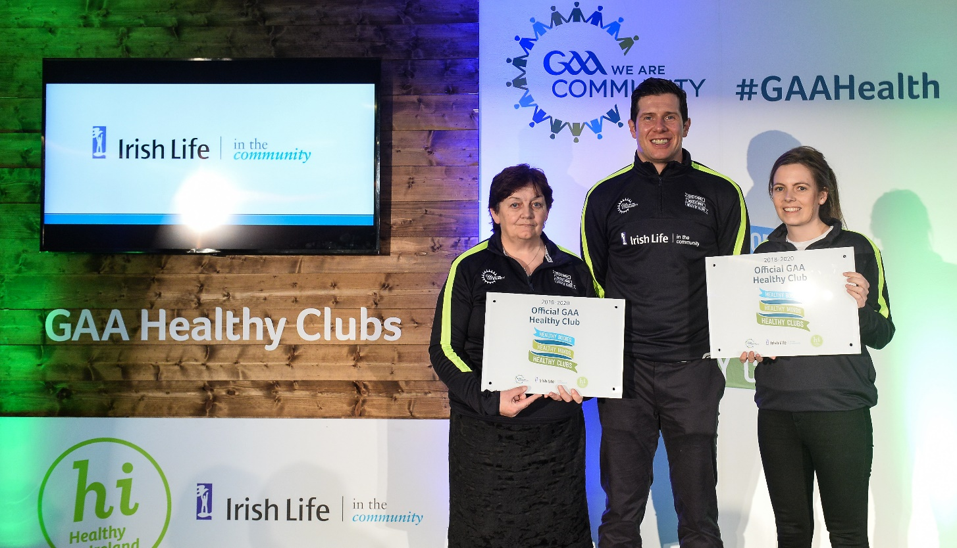
PRESENTATION OF HEALTHY CLUB CERTIFICATES TO BALLYDONOGHUE & DR CROKES GAA CLUBS
