MENTAL HEALTH INITIATIVE – RAISING AWARENESS IN CLUBS
The Kerry Health and Wellbeing Committee partner with Kerry Mental Health Association and Jig Saw Kerry who are available to make presentations to clubs, on request.
The Kerry Health and Wellbeing Committee also organise safeTALK, for Clubs or Distirct Committees, in association with the HSE, who deliver these workshops.
Jigsaw will be presenting a workshop (My Mental Health What Helps) at the National Youth Forum in Croke Park, next October.
Information about talks & presentations available to clubs through the Kerry Health and Wellbeing Committe are below. See also www.gaa.ie >Community & Health
Kerry GAA have adopted a Critical Incident Response Plan which is available in a seperate attachment.
________________________________________________________________

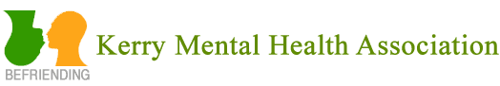
Kerry Health & Wellbeing Committee Member: Ned Brosnan 087 7444964
Kerry Mental Health Association is a voluntary organisation that supports people with Mental Health difficulties. It promotes positive Mental Health through Health promotion and in this instance with Kerry GAA and individual clubs. Kerry mental Health assists through talks to Officers, Coaches and Individuals, within clubs to identify and support members where issues arise in their life, it provides guidance to assist in signposting to the appropriate services.
Fuether Details: www.kerrymentalhealth.com
________________________________________________________________
Ned Brosnan is available to clubs to make the following Presentations
Self-Harm and Impulsive Behaviours Presentation
Aim of presentation:
- To define Self-Harm & Impulsive Behaviours
- Look at incidence
- Risk factors
- Signs relating to self-harm
- What we can do to help

Suicide Awareness Presentation
Aim of presentation:
- To enhance participants awareness of suicide
- Be able to identify the risk factors and list the signs associated with suicide
- Outline a response to a suicidal person
- Possess knowledge of services available to support people in distress

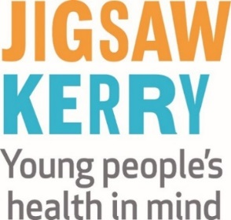
T 066 7186785 email: kerry@jigsaw.ie Web site: www.jigsaw.ie/kerry
Kerry Health & Wellbeing Committe Member: Jimmy Mulligan
Our workshops increase community awareness and understanding of youth mental health, and strengthen the knowledge and confidence of people who work or volunteer with young people.
__________________________________________________________________________
It’s Time to Start Talking
This one hour presentation for 13 -17 year olds encourages young people to talk with someone they trust when feeling stressed, worried or down.
As a result of this presentation, young people will:
- Gain an understanding of mental health
- Become aware of what helps and hurts their mental health
- Gain an awareness of the importance of talking to a trusted adult when they feel down, worried or stressed
- Learn how and where to get help
Supporting Young People’s Mental Health
This one hour presentation is for parents, guardians and other adults interested or concerned about young people’s mental health.
As a result of this presentation, participants will:
- Gain an understanding of the key issues impacting on the mental health and wellbeing of young people
- Learn to promote mental health in young people
- Understand how to recognise some of the signs that a young person may be struggling with their mental health
- Learn the value of listening as a way of supporting young people
- Increase knowledge of the supports available in their local area
One Good Coach: Promoting Young People’s Mental Health
This one hour presentation is aimed at One Good Adults who coach or train young people in a wide variety of sports
As a result of this presentation, participants will:
- Have a greater understanding of mental health
- Have a greater understanding of the importance of their role as One Good Adult
- Have a greater awareness of how to promote and support young people’s mental health in their role as coach
- Learn about their local Jigsaw and how young people can access the service
_________________________________________________________________________________
THE LITTLE THINGS CAMPAIGN (WWW.YOURMENTALHEALTH.IE)
The GAA and the HSE are working in partnership to bring the messages of protection, resilience and support for mental wellness to local communities. Both organisations are keen to increase their efforts to normalise the conversation around mental health.
The #littlethings campaign highlights that we all experience difficult times in our lives, and that when we do, there are some evidence-based ‘little things’ that can make a big difference to how we feel.
__________________________________________________________________________________

